**Standard Wording use in Patient Summaries- Spanish**

**Spanish Summary Title**: Tratamiento del sarcoma de Ewing

**Summary CDR ID**: 583660

Most *Standard Wo*rding terms and definitions in ES summaries are inside **StandarWording** tags.

1. Example of *Standard Wording* used under “Treatment Option Overview” section. In this section, *Standard Wording* is used inside **Para** tags.

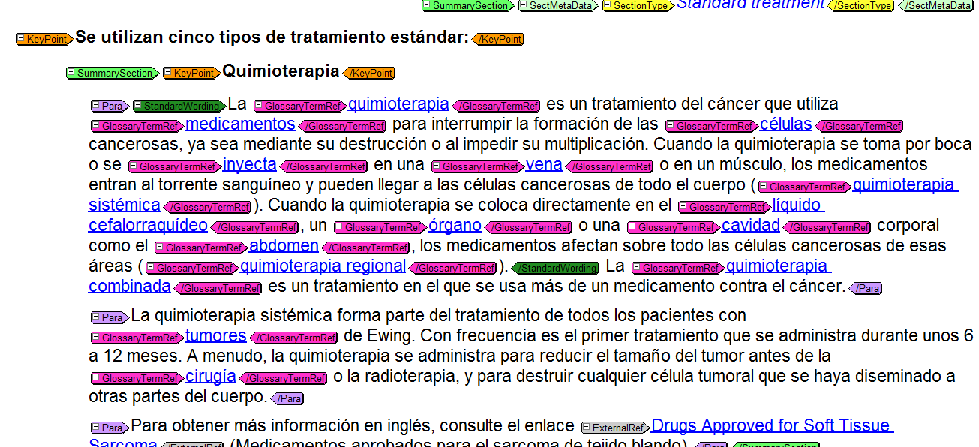

**REDACCIÓN ESTANDAR (STANDARD WORDING) MISC. DOC, CDR ID 466628**

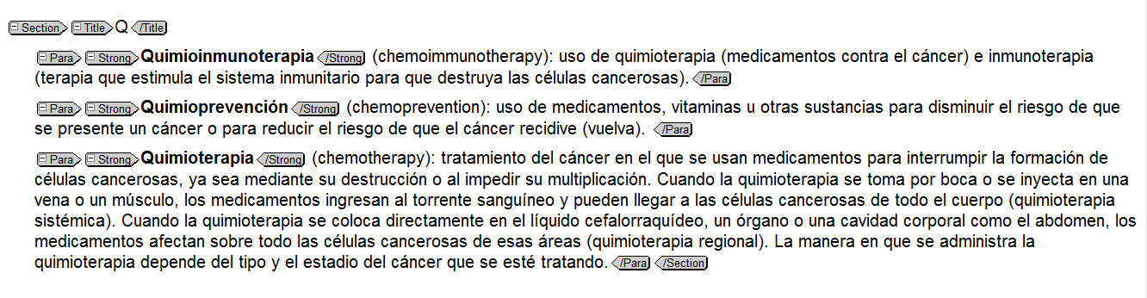

1. Example of an itemized list under “*Test and procedures*” section where *Standard Wording* for tests and procedures is used.

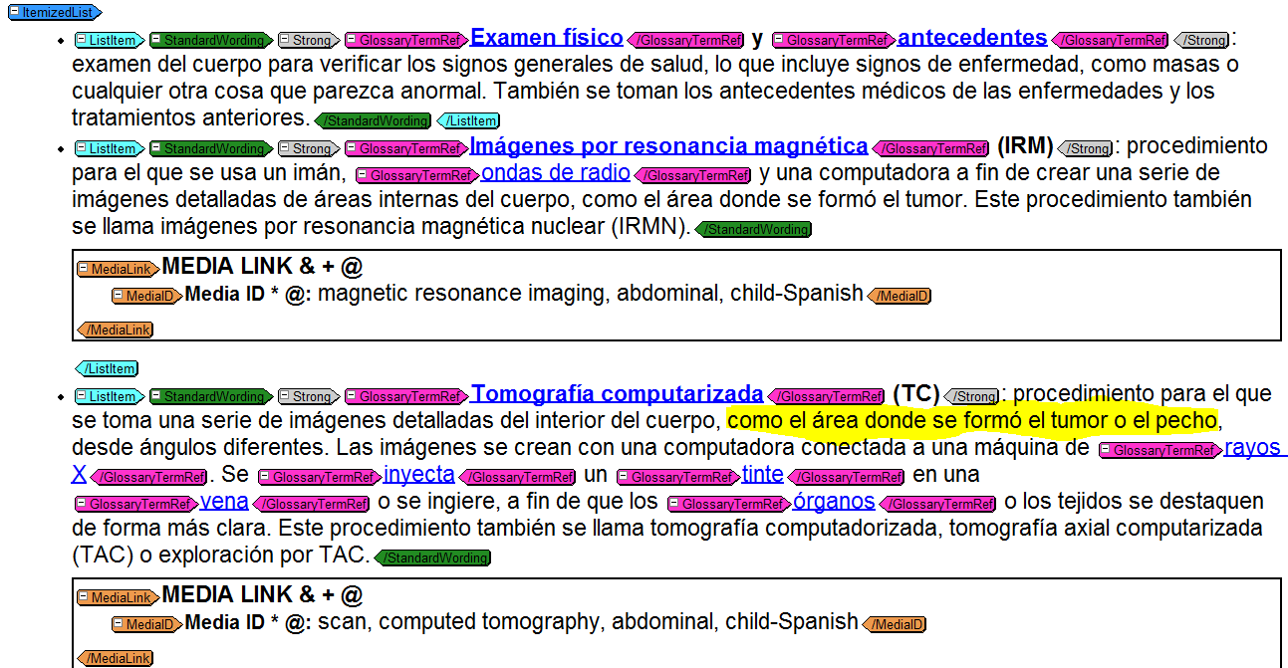

The text highlighted in yellow was tailored for the above standard wording. It’s not a part of the definition for this procedure in the Standard Wording document. See example below.

**REDACCIÓN ESTANDAR (STANDARD WORDING) MISC. DOC, CDR ID 466628**

